A Summary on **The Enron Email Dataset**

The research on The Enron Email datasets derive a social network constituting of151 employees from the email logs, by defining a social contact to be someone with whom an individualhas exchanged a pre decided threshold number of emails.

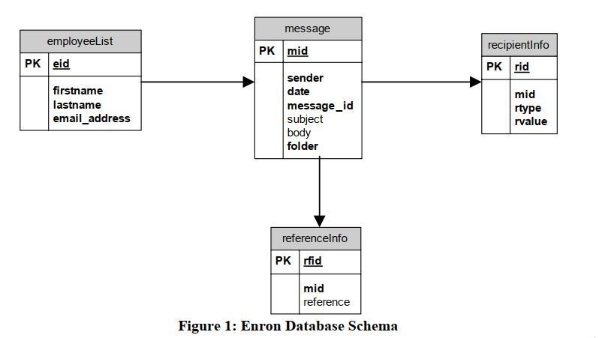

From several graph representation, the report showed-

1. Distribution of emails per user
2. Distribution of Sent emails per user
3. Distribution of emails over time (Year)

The report derived a social network from the dataset. This network constitutes of 151 employees of Enron. The basic definition of a social contact between two employees is a predefined threshold number of exchange of emails. The threshold we consider here is 5.It considered only bidirectional links, this means that it is considered a contact only if both have sent emails to each other. This guarantees that there has been some exchange of information between the two employees of Enron and hence they are involved in some kind of conversation. It also considered the position of every employee in the organization hierarchy to manifest  
the flow of information in an organization.

